Assignment V

- Generate a graph using the Barabási-Albert preferential attachment model. Begin with a pair of nodes with a single link between them. Go for eight steps. At each step, add one node and a single link connecting it to the previous graph.

- Draw each step, writing down the appropriate probability next to each node to indicate how likely it is that the new node will attach there. (Note: When you have a set of preferences for different options, for instance, things you prefer with weights 5, 2, and 1, you convert them into probabilities by summing them, 5+2+1 = 8, and dividing each one by the sum: 5/8, 2/8, 1/8. Again, you can use random.org as a source of random numbers.)
- What is the degree sequence of your final graph?
- What is the expected degree sequence of a graph with this number of edges and this number of vertices that is generated in this manner?

- Prove that for sub-linear kernels, which are asymptotically homogeneous,

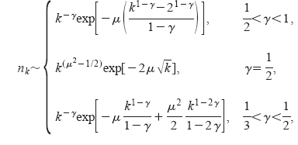
where k, μ, γ and n_{k} refer to their standard meanings.

- It can be shown (from Yule Distribution), that for a power-law for integer variables the following holds:

p(k) = C B(k, α) = C (Γ(k) Γ(α)/ Γ (k+ α))

where C is a normalizing constant and Γ(x) is the standard Γ-function with the property Γ(x+1) = x Γ(x).
₁
Consider the integral I(a, b) = ∫ u^{a-1}(1-u)^{b-1}du
₀

Show, using integration by parts, that for a>1 and b>0,

I(a, b) = (^{a-1}/_{b})I(a-1,b+1)

Hence, by the repeated use of the above formula show that for k integer,
₁
B(k, α) = ∫ u^{k-1}(1-u)^{α-1}du
⁰
Further show that C = α – 1, given ∑p(k) = 1
Also show that,
∑kp(k) = ^{α – 1}/ _{α – 2}

If y = k(1-u), then show that in the thermodynamical limits,

p(k) = (α – 1) Γ(α)k^{- α}

- Begin by drawing a regular graph: arrange 12 nodes in a circle and connect each node to the four nodes nearest to it — that is, the two nodes to one side of the node and the two nodes to the other side along the circle.

  - Compute the average distance between all pairs of different nodes.
  - Make a single rewiring which minimizes the average distance.
  - Why is it now much harder to compute the average distance on this modified graph?

